TABLE OF CONTENTS #

Table of Contents 1

# Abstract 2

## Acknowledgments 3

Introduction 4

*Bacillus Cereus*  4

*Sulfur* 5

*What is an anti-bacterial?* 6

*Bentgrass* 6

Problem 9

*Hypothesis* 9

*Prediction* 9

# Materials 10

Procedure 10

Data/Results 12

*Statistical Analysis* 14

*Graphs* 16

Conclusion 18

Recommendations 19

References 20

*Bibliography*  20

Photographs 22

Daily Log 29

# **Abstract**

When choosing a topic for this year’s Science Fair, we decided on an issue that dealt with both plants and bacteria. Last year, a group that entered the fair from our school focused on garlic, which has a high sulfur content, as an antibiotic. After reading their analysis, we were very intrigued by the topic of plants and it’s anti-bacterial properties. Sulfur studies have indicated antibiotic properties that we wanted to investigate even further. Our topic led us to explore the possibility of an experiment. We could subject certain grasses to sulfuric conditions and see if it would give the grasses a more intense antibiotic possession. From this experiment, we are hoping to find that grasses will directly be influenced by the sulfur concentration in the soil. If there is more sulfur in the soil, then perhaps the grasses will have a stronger reaction as an antibiotic.

# **Acknowledgments**

First of all, we would like to say that none of this could have been possible without the help of these individuals who have supported us throughout our project.

We would like to thank Ms. Ann Deutch from the Yellowstone National Park, who gave us the specific grass species to use for our project. With her help, we were able to obtain a grass species that grows well in high amounts of sulfur concentration. We would not have been able get started without this vital information that she has given to us.

Next, we want to thank Ms. Lorraine from the Pacific Coast Seed Inc. for providing us with the grass seeds that we needed. She gave us more than enough out of her generosity in order for this project to be under way.

We also wish to thank Mr. Simms of Amador Valley High School for providing us with his equipment, his time, and his energy. He helped us grow our plants when the school greenhouse wasn’t working properly.

Last but not least, we would like to give a round of applause to our AP Biology teacher, Mr. Thiel. Without him, none of this would have been possible. Mr. Thiel, with his unfailing patience, has given his heart, time, energy, equipment, ideas, unconditional support, and his yummy supply of wheat thins. Besides, we know that when he says, “Ah Geez!” or “You’re killing me, J.A., you’re killing me!” it’s just another way of him showing us that he cares for us. Thank you Mr. Thiel.

**Introduction**

Humans are thought to be able to accomplish anything as long as they work together. They put a man on the moon, cloned animals, mapped the human genome, and even sent a rocket to Mars. However, there are still many mysterious things that humans cannot comprehend or figure out. The Ebola virus, Mad cow disease, Foot and hands disease, and HIV are a few diseases and viral infections that scientists cannot solve. Ebola is known to have an 88% fatality rate in Zaire and 55% fatality rate in Sudan. Those are very frightening statistics. Even though we are in the midst of scientific advancement, there are still some things that we cannot figure out. No matter how hard we humans try, we cannot rid the world of viruses or bacterium that cause illnesses in humans. But, as long as we are here on this planet, we will always try to find a cure in order to save an individual’s life.

## **OUR BACTERIA: Bacillus cereus**

## Bacillus Cereus is known to cause two distinct types of illnesses: one, a diarrheal illness with an incubation time of approximately 4 to 16 hours, and two, a vomiting illness with an incubation time of approximately 1 to 5 hours. Incubation is the time it takes for the bacteria to take effect. The vomiting illness strains are often associated with rice and other starchy food. The diarrhea illness is commonly associated with meats, fish, and vegetable. Symptoms can last up to 24 hours. It’s widely distributed in nature and in foods, and commonly found in soil, milk, cereal, starch, meat, and vegetable produces. Foods most often implicated in outbreaks include meats, pie, and fried rice (Bacillus Cereus, #19). All people are believed to be susceptible, or vulnerable, to Bacillus Cereus (so watch out!). Bacillus Cereus hasn’t been thought to be life-threatening until recently; there have been a strain of Bacillus Cereus able to produce enough toxins to cause liver failure. This prokaryote is so widespread, that it’s very difficult to keep it from contaminating food. Bacillus Cereus is able to produce spores that can survive dryness and mild heat treatments, such as cooking. Freshly cooked food eaten hot, and immediately after cooking is safe. Steaming under pressure, roasting, frying, and grilling are most likely to destroy the bacillus cell and it’s spores. However, temperatures under 212 F will allow the survival of some spores (Bacillus Cereus, #19).

## **SULFUR: History**

In 2000 B.C., sulfur was used to bleach cotton and linen. Egyptian paintings as early as 1600 B.C. contained sulfur derived colors. We can conclude from this that sulfur has been used by people in their daily lives. Sulfur is referred to brimstone in the Bible and is the fuel in the fires of Hades. Sulfur was also used as a disinfectant in the time of Homer. It wasn’t recognized as an element until the 1800’s (Watt #1).

**SULFUR: Scientific Information**

|  |  |  |  |
| --- | --- | --- | --- |
| **NAME** | Sulfur | **GROUP #** | 16 |
| **SYMBOL** | S | **GROUP NAME** | Chalcogen |
| **ATOMIC WT** | 32.066 | **PERIOD #** | 3 |
| **ATOMIC #** | 16 | **BLOCK** | p-block |

Sulfur is essential in all life forms including microorganisms, plants, and animals. It is a minor constitute of fats, body fluids, and skeletal minerals. Pure sulfur is tasteless, odorless, brittle-solid, that is pale yellow. It is a poor conductor of electricity and is insoluble in water. Sulfur exists in several different forms. The two most important forms are orthorhombic and monocline crystalline modifications. Sulfur burns easily and gives a blue flame and pungent fumes. It is known as an allotropic element and is a solid non-metal. Sulfur makes up 0.06% of the Lithosphere and 0.09% of water in the sea (Britannica, #5). Organic sulfur is a component of many living things; cabbages, turnips, mustard greens, onions and garlic are all high on sulfur (Lam, #11). Large amounts of the element associated with volcanic vents that are found in Japan and Chile. Smaller deposits are found in hot springs such as the Mammoth Hot Springs in Yellowstone Park. It is not normally necessary to make sulfur in a laboratory because it’s so readily available. It is found as a native element in nature and is extracted by the Frach process. This means that sulfur can be extracted from underground without mining for it. In the Frach process, the underground deposits are forced to the surface using super heated water and steam and compressed air. Purity of sulfur can reach up to 99.5% and the process is energy exhaustive (Watt, #1). Sulfur Dioxide is a dangerous component in atmospheric pollution and is one of the factors that cause acid rain (Encarta, #8).

## **WHAT IS AN ANTIBACTERIAL?**

The ideal antibacterial compound displays a selective toxicity. This means that it is harmful to the microbe (bacteria or virus) without being harmful to the host (you). In reality, many antibacterials have a relative toxicity. Antimicrobial is a broader category that includes anti-fungal, anti-viral, anti-protozoal, or anti-bacterial compounds.

Antibacterial specifically act against bacterial cells (What is an Antibiotic?, #15). The actual mechanism of anti-bacterial components is not always known. In general term, most of these drugs act by altering or inhibiting one of the following structures or processes:

* cell wall synthesis
* permeability of the cell membrane
* protein synthesis
* nucleic acid synthesis

## **BENTGRASS**

Bentgrass (Agrostis) is a large genus with over 100 species. It flourishes throughout the New England states and the Pacific Northwest, where climate conditions are ideal for bentgrass. This species of grasses are primarily used for lawns, athletic fields and golf courses. This grass is common in Europe and Asia as it is commonly found in lawns, pastures, and sports fields (Agrostis #20).

## **BENTGRASS: Creeping Bentgrass Description**

Creeping Bentgrass (*Agrostis palustris*) is a cold season grass that forms a dense mat. The grass spreads to profuse creeping stems and possesses rather vigorous shadow roots. Stems (stolons) are creeping and slender, and produce long, narrow leafs. Leaf blades are smooth on the upper surface and rigid on the underside, 1 – 3 mm wide and bluish green in appearance. The ligule is long, membranous, finely toothed, or entire and rounded, auricles are absent. The species are characterized by single, flowered, spikelets in a compact panicle. The panicle in flower is purple to bronze in appearance. Seeds of creeping bentgrass are too small to be identified without a magnifying glass. Seeds are oval in shape and less than 1 mm long. They are usually silver in appearance (Bentgrass, #18).

## **BENTGRASS: Spiked Bentgrass Description**

Spiked Bentgrass (*Agrostis exarata*) has many forms. Some are tall, some are short, but ordinarily, they are usually 30-60 cm tall. They have flat blades, which are always dense, but vary in length and thickness. They are native on rather moist soil, and in various habitats and plan associations. This grass is perhaps best developed in the mountains and along the north coast. The species, with it’s many forms, occurs throughout the western half of the U.S. as far north as Canada and Alaska, and as far south into Mexico. Spike bentgrass is particularly abundant along streams, in or about meadows, moist slopes, or moist clearings in the forest. The green foliage and soft seed head are used by grazing animals in the mountains during most of the summer. Though excessive or too close grazing may drastically reduce the density of the grass. On disturbed soils, the grass soon forms a good stand, but over many years, diminishes because of competition between other plants (Bentgrass, #18).

## **BENTGRASS: Pacific Bentgrass**

Pacific Bentgrass (*Agrostis avenacea*) can get to 30-60 cm tall. The blades can be 3 to 8 mm wide. It tends to behave as a tumble weed. Introduced from Australia, naturalized mostly in the central valley, but extending into the surrounding foothills, delta region, and around the San Francisco Bay. Pacific Bentgrass occurs abundantly in old rice fields or pastures or marshlands. By late spring, it has widely dispersed its airy wind transported panicles, while pile up in ditches and fences conspicuously (Agrostis, #20).

## **BENTGRASS: Adaptation and Use**

Bentgrass is adapted to cool, humid environments such as those found in the northeastern United States. Cold, nighttime temperatures are particularly advantageous to bentgrass. In the south, high daytime temperatures together with warm, nighttime temperatures create highly adverse conditions for bentgrass. During the summer months in the south, carbohydrate reserves are depleted in bentgrass and the turf becomes susceptible to additional stress: drought, shade, insects, or disease. As a result, the only use of bentgrass in the south is for golf greens, where small acreage allows for intense management. In the south, bentgrass is best adapted to the transition zone where cooler temperatures prevail (Agrostis, #20). But even in this area, special attention needs to be given for soil preparation, water management, air circulation, shade, exposure, and other factors.

## **BENTGRASS: Preparation**

In the case of bentgrass, particular attention needs to be given to seed bed preparation. Well drained soil mixtures are essential for growing bentgrass in the south. Highly permeable mixtures of sand and organic adjustments placed over a drainage system are commonly used for a bentgrass green. Frequent fertilization is helpful to establish a cover of bentgrass. Early fall is the best time to see bentgrass. Spring planting dates do not allow adequate growing time for plants to mature prior to summer stress.

## **BENTGRASS: Management**

Management and frequent observation are keys to the success of bentgrass. Watering, fertilization, mowing, cultivation, and pests must be closely managed to keep the bentgrass green. Water must be closely managed to meet the moisture needs of the grass. Water also serves to monitor the temperature during heat stressed periods. To control insect and disease level, frequent surveillance needs to take place. If worms and crickets are found, the grass needs to be treated immediately (Agrostis, #20).

# **Problem**

Are bentgrasses that are found in high levels of sulfur capable of having anti-bacterial property?

# **Hypothesis**

Bentgrasses found in higher levels of sulfur concentration will have an increase effectiveness of controlling bacterial growth.

# **Prediction**

If Bentgrass is grown in higher levels of sulfur concentration, then it will possess a better anti-bacterial property.

# **Materials**

|  |  |  |  |
| --- | --- | --- | --- |
| 1000 ml beaker | Bentgrass | Gloves | Mortar & Pestle |
| 500 ml beaker (2) | Bunsen Burner | Graduated Cylinder | Paper Towel |
| Agar powder | Calculator | Hole Punch | Petri Dish |
| Ammonia | Chromatography | Hot Plate | Scale |
| Aprons | Distilled Water | Inoculation loop | Tweezers |
| Bacillus cereus | Glass Stirring Rod | Matches | Well Plate |

**Procedure**

Preparing the Agar plate

1. Open and pour 23 g of agar nutrient powder.
2. Pour 1000 ml of distilled water into a1000 ml beaker.
3. Separate the 1000 ml solution into two 500 ml beakers.
4. Plug in two hot plates and set the two 500 ml beakers on it.
5. Stir the agar solution with a stirring rod. Heat the solution until the powder/particles disappear.
6. Pour agar solution into 30 petri dishes approximately 1/3 of the petri dish high, or enough to cover the bottom of the dish.
7. Let agar solution cool off for about 15 minutes until it turns into gel.

Preparation before adding the bacteria

1. Wipe down the lab table with ammonia before starting.
2. Sterilize the tweezers and the inoculation tubes before opening the bacteria vial.
3. Wear rubber gloves

Making the Solution

(Repeat steps 15 times)

1. Obtain a well plate with six holes.
2. Take the roots of the creeping bentgrass, pacific bentgrass, and the spike bentgrass grown in 0% sulfur soil concentration.
3. Ground the roots from each of the bentgrass separately using a mortar and pestle.
4. Add 1 ml of distilled water into the mortar as the roots are being crushed to make a small solution.
5. In the well plate, put each species of bentgrass in each hole.
6. Label the well plate with (a), (b), (c), (d), (e), and (f).
7. = Pacific Bentgrass at a certain %
8. = Creeping Bentgrass at a certain %
9. = Spike Bentgrass at a certain %
10. = no solution
11. = distilled water
12. = distilled water and soil
13. Add one disk of chromatography paper to each well. (d) is just chromatography paper. Leave each circle in the solution for approximately 10 minutes.
14. Label a petri dish with the trial number and divide the dish with a wax pencil into 6 areas. Label it (a) – (f) in clockwise arrangement.

Adding the Bacteria

1. Take a vial of Bacillus cereus and sterilize the opening with ammonia.
2. While wearing gloves, take the inoculation tube and put it into the vial of bacillus cereus.
3. Stroke up and down with the inoculation tube on the agar carefully, spreading the bacteria in a criss-cross manner. Repeat process twice on each plate.
4. Do this process to each agar plate.

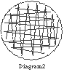

Adding the Chromatography paper

1. Take the well plate with 6 different chromatography paper disks and using sterilized tweezers, pick each disk up and put it on the corresponding part of the agar plate. So, (a) with (a), (b) with (b), and so on and so on.
2. Cover the plate quickly after adding the chromatography paper.
3. Let the plates alone for 24 hours after adding the chromatography disks.

Collecting the Data

1. After a 24-hour period, take the petri dishes and measure the zone of inhibition if any is seen.
2. Record in Data Chart and Graph.

# **Data**

0% Sulfur Concentration Trial 1: Zone of Inhibition

|  |  |  |  |  |  |
| --- | --- | --- | --- | --- | --- |
| Pacific Bentgrass | Creeping Bentgrass | Spike Bentgrass | Distilled Water | Soil with sulfur 0% | No solution only paper |
| none | none | none | none | none | none |

0% Sulfur Concentration Trial 2: Zone of Inhibition

|  |  |  |  |  |  |
| --- | --- | --- | --- | --- | --- |
| Pacific Bentgrass | Creeping Bentgrass | Spike Bentgrass | Distilled Water | Soil with sulfur 0% | No solution only paper |
| none | none | none | none | none | none |

0% Sulfur Concentration Trial 3: Zone of Inhibition

|  |  |  |  |  |  |
| --- | --- | --- | --- | --- | --- |
| Pacific Bentgrass | Creeping Bentgrass | Spike Bentgrass | Distilled Water | Soil with sulfur 0% | No solution only paper |
| none | none | none | none | none | none |

10% Sulfur Concentration Trial 1: Zone of Inhibition

|  |  |  |  |  |  |
| --- | --- | --- | --- | --- | --- |
| Pacific Bentgrass | Creeping Bentgrass | Spike Bentgrass | Distilled Water | Soil with sulfur 10% | No solution only paper |
| none | 0.5 mm | none | none | 1 mm | none |

10% Sulfur Concentration Trial 2: Zone of Inhibition

|  |  |  |  |  |  |
| --- | --- | --- | --- | --- | --- |
| Pacific Bentgrass | Creeping Bentgrass | Spike Bentgrass | Distilled Water | Soil with sulfur 10% | No solution only paper |
| 2 mm | 1 mm | none | none | 1 mm | none |

10% Sulfur Concentration Trial 3: Zone of Inhibition

|  |  |  |  |  |  |
| --- | --- | --- | --- | --- | --- |
| Pacific Bentgrass | Creeping Bentgrass | Spike Bentgrass | Distilled Water | Soil with sulfur 10% | No solution only paper |
| 1 mm | none | 1 mm | none | none | none |

25% Sulfur Concentration Trial 1: Zone of Inhibition

|  |  |  |  |  |  |
| --- | --- | --- | --- | --- | --- |
| Pacific Bentgrass | Creeping Bentgrass | Spike Bentgrass | Distilled Water | Soil with sulfur 25% | No solution only paper |
| .25 mm | 2 mm | 1 mm | none | .5 mm | none |

25% Sulfur Concentration Trial 2: Zone of Inhibition

|  |  |  |  |  |  |
| --- | --- | --- | --- | --- | --- |
| Pacific Bentgrass | Creeping Bentgrass | Spike Bentgrass | Distilled Water | Soil with sulfur 25% | No solution only paper |
| 1 mm | 1.5 mm | none | none | 1 mm | none |

25% Sulfur Concentration Trial 3: Zone of Inhibition

|  |  |  |  |  |  |
| --- | --- | --- | --- | --- | --- |
| Pacific Bentgrass | Creeping Bentgrass | Spike Bentgrass | Distilled Water | Soil with sulfur 25% | No solution only paper |
| 1.5 mm | 2 mm | 2 mm | none | 3 mm | none |

50% Sulfur Concentration Trial 1: Zone of Inhibition

|  |  |  |  |  |  |
| --- | --- | --- | --- | --- | --- |
| Pacific Bentgrass | Creeping Bentgrass | Spike Bentgrass | Distilled Water | Soil with sulfur 50% | No solution only paper |
| 1.5 mm | none | 3 mm | none | 1 mm | none |

50% Sulfur Concentration Trial 2: Zone of Inhibition

|  |  |  |  |  |  |
| --- | --- | --- | --- | --- | --- |
| Pacific Bentgrass | Creeping Bentgrass | Spike Bentgrass | Distilled Water | Soil with sulfur 50% | No solution only paper |
| .5 mm | none | none | none | 2 mm | none |

50% Sulfur Concentration Trial 3: Zone of Inhibition

|  |  |  |  |  |  |
| --- | --- | --- | --- | --- | --- |
| Pacific Bentgrass | Creeping Bentgrass | Spike Bentgrass | Distilled Water | Soil with sulfur 50% | No solution only paper |
| 1.5 mm | 2 mm | 1 mm | none | 2 mm | none |

75% Sulfur Concentration Trial 1: Zone of Inhibition

|  |  |  |  |  |  |
| --- | --- | --- | --- | --- | --- |
| Pacific Bentgrass | Creeping Bentgrass | Spike Bentgrass | Distilled Water | Soil with sulfur 75% | No solution only paper |
| none | 1 mm | 2 mm | none | none | none |

75% Sulfur Concentration Trial 2: Zone of Inhibition

|  |  |  |  |  |  |
| --- | --- | --- | --- | --- | --- |
| Pacific Bentgrass | Creeping Bentgrass | Spike Bentgrass | Distilled Water | Soil with sulfur 75% | No solution only paper |
| 1 mm | 0.5 mm | 1.5 mm | none | 2 mm | none |

75% Sulfur Concentration Trial 3: Zone of Inhibition

|  |  |  |  |  |  |
| --- | --- | --- | --- | --- | --- |
| Pacific Bentgrass | Creeping Bentgrass | Spike Bentgrass | Distilled Water | Soil with sulfur 75% | No solution only paper |
| 1.5 mm | 2.5 mm | 2 mm | none | none | none |

# **Results**

To our belief, sulfur seemed to have an effect on bacteria. Looking at our data and our graph, we noticed that the chromatography paper and distilled water, did nothing to bacterial growth, but the other plants which were grown in sulfur concentrations did show a small ring of inhibition. There are many factors in this experiment, such as the amount of sulfur, the amount of bacteria, temperature, how much distilled water into each solution, and the amount of roots that were grounded up. We tried our best to keep everything equal, but there could have been some human error between them. Our results weren’t as powerful as we expected, but the results are in favor of our hypothesis. At 75% sulfur concentration, the third trial seemed to do real well because all three species of bentgrass: Pacific, Creeping, and Spike, showed some results. In each sulfur concentration, however, the chromatography paper soaked in the soil concentration seemed to have some effect on bacteria as expected.

##### **Statistical Analysis**

From our data, we conducted a one-way analysis of variance (ANOVA) test that compares the means of several populations. The ANOVA F test tests overall Ho that all the populations have the same mean. If the F test shows significant differences, the data will show that the different concentrations of sulfur will make a difference on the zone of inhibition.

Assumptions:

1. We conducted an independent SRS (Simple Random Sample) from each population
2. Each population has a normal distribution
3. All populations have the same standard deviation

Hypothesis:

Ho: The sample means of each population are equal

Ha: Not all of the populations’ means are equal

The mean squares that make up F: (the equation)

2 2

MSG= n1(x1-x)+n2(x2-x) +….

I-1

&

2 2

MSE= (n1-1)s1+(n2-1)s1+……

N-1

For the sake of simplification, we were able to use a calculator program that did this kind of math for us. We used a TI-83 statistic math program that preformed the ANOVA test for us. For more details on how to do this test by hand please consult:

Moore, David S. The Basic Practice of Statistics. W.H. Freeman and

Company, New York. 1995

Here are our results from the ANOVA test:

Testing all levels of Sulfur with combined grasses

F=1.3559 P=.2738

Based on the p-value of .2738, we failed to reject the Ho at the 5% level. There is not enough convincing information so the sample means of each population aren’t statistically significant.

Testing Pacific Bentgrass at each level

F=1.34 P=,3202

Based on the p-values of .3202, we fail to reject the null hypothesis once again at the 5% level

Testing Creeping Bentgrass at each concentration level

F= 2.83 P=.083

Even though this p-value is close to rejecting the Ho and therefore showing significance, we still fail to reject the null hypothesis. There is still no strong data to prove that our data collection showed a difference of sulfur concentration

Testing Spike Bentgrass at each concentration level

F=2.2 P=.142

Once again there is no significance between the different concentrations of sulfur at the p-value of .142 at the 5% significance level.

Testing the soil at each level

F=1.867 P=.193

There isn’t enough evidence to reject the Ho. The means of each population at different concentrations of sulfur are the same. There is no significance of variance.

**Graphs \***

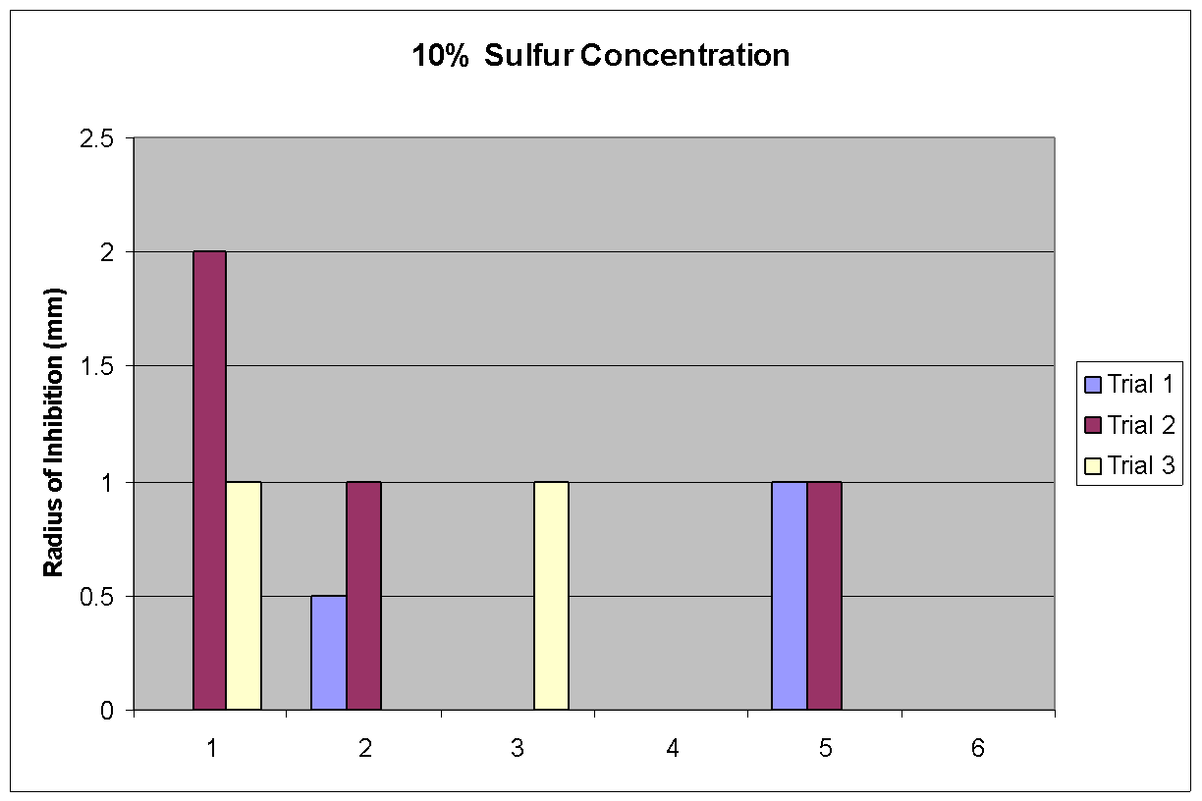

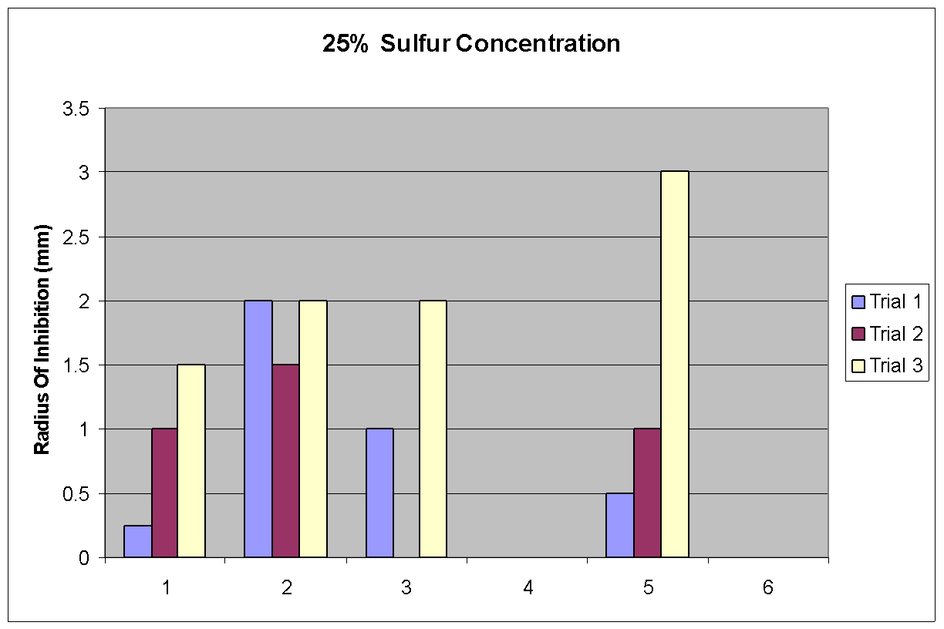

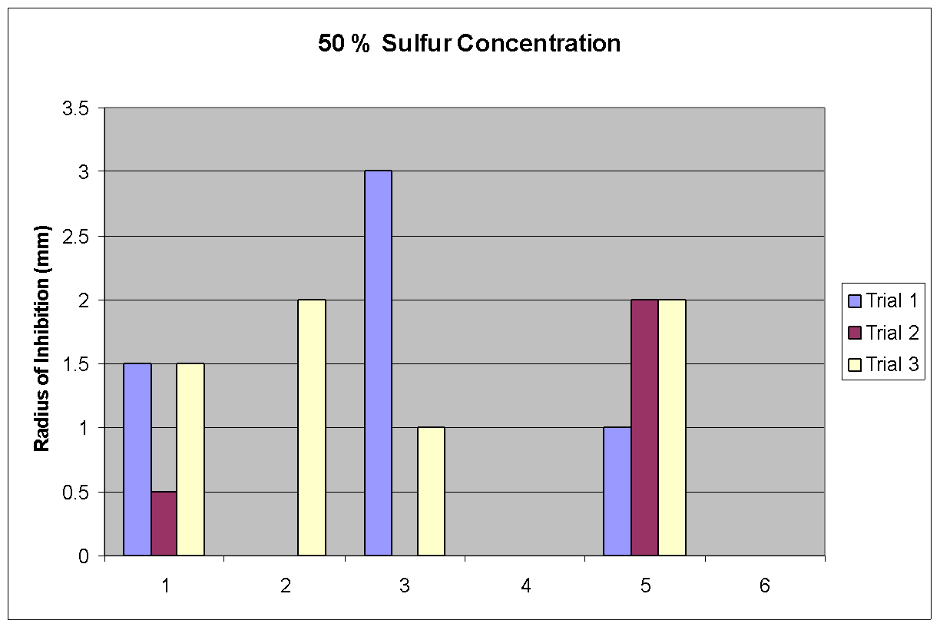

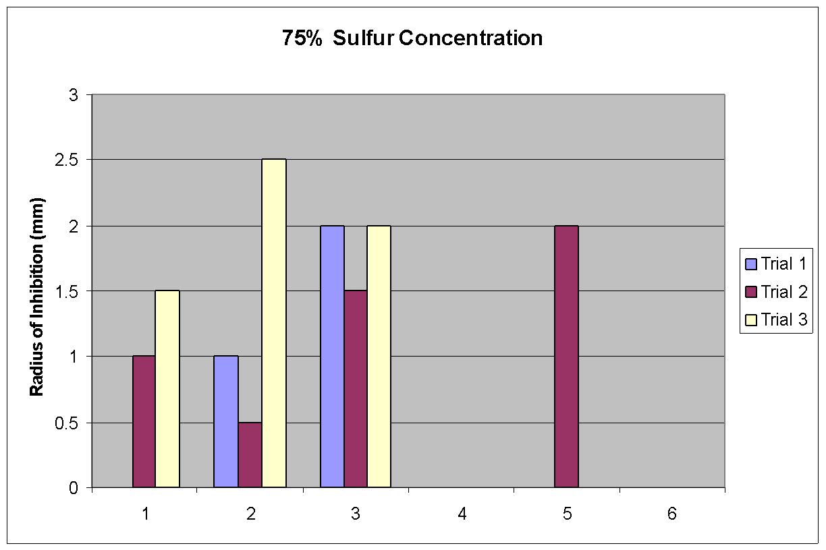

* Key: (1) Pacific Bentgrass, (2) Creeping Bentgrass, (3) Spike Bentgrass, (4) Chromatography paper only, (5) Distilled Water, and (6) % concentration soil

# **Conclusion**

Based on our experiment, the data seems to favor our hypothesis. It is seen in our graphs, data, and results, that the sulfur concentration did seem to have some effect on bacterial growth compared to just the chromatography paper and distilled water. We can conclude that distilled water and chromatography paper has no effect on bacteria at all. This experiment is a foundation experiment that opens doors to other research dealing with plants and antibiotics. Even with 3 trials, our experiment didn’t give strong enough data to flat out state that our hypothesis was 100% correct.

Based on our statistical analysis using the ANOVA test that tested the variance and significance between data, our experiment was unable to support our hypothesis. However, since our data did indicate some change in growth of the bacteria we suggest further investigating. Our graphs seem to support the significant decrease in bacteria growth at higher levels of sulfur concentration, but after the ANOVA test, we were proved incorrect. There is somewhat a decrease of growth, but not enough to prove to be a difference of sulfur concentrations.

Sulfur has already been found to carry an antibacterial trait. It has been proved that sulfur pills have been used as an antibiotic. Our best bet is that if you put a large chunk of sulfur in a bacteria filled petri dish, the bacteria will most likely disperse from that area.

Bentgrass was used because species of bentgrass have been found in the Hot Springs of Yellowstone Park. It was a plant that we knew could live in sulfuric conditions and grow exceptionally well.

Our findings are an important start to other experiments to come.

# **Recommendations**

This experiment was thought to be planned well, but as we expected, it wasn’t perfect.

This experiment is the foundation for many other experiments that deal with plants and antibiotics. Using this experiment as a basis, other experiments can take place dealing with plants that actually have high levels of sulfur in it. To further investigate the effect of sulfur and it’s antibacterial property, more research can be done such as comparing and contrasting the results obtained from the experiment to that of the garlic. Additional studies can be done.

First, it would be ideal for the experiment to take place in a clean room. A sterilized room will decrease the chances of other bacteria species to mix in with our Bacillus cereus. It can change the results of the experiment to be more precise than it is. Everything needs to be controlled, so, only the same species of bacteria should be used for all the tests.

The bacteria grow well in almost any room temperature. It just takes a little longer than it does in a warmer condition. A recommendation is to put the bacteria petri dishes into an incubator and keep it in there for a specific amount of time. This will speed up the multiplying process of the bacteria and enable the “scientists”, or the individuals performing the experiment, to see a better result of the experiment.

Another small recommendation is to keep the plants grown, in a stable condition. In other words, don’t put the plants in a cold place if it is expected to grow. Put it in a functioning greenhouse or a under a small lamp to keep the plants growing and warm. This will save plenty of time.

Be accurate in everything that you do. Try to rid the soil from the roots as much as possible. Measure the amount of water, the mass of the agar, and the amount of sulfur, as precisely as possible. The more accurate the procedure is done, the more accurate the results will be.

When using sulfur, make sure the sulfur is in the smallest pieces possible so that it can mix in with the soil as easily as it can.

Further tests can be done with other bacteria to see the effects of these plants with other bacteria species.

**References**

For our project, we had many sources other than books. We needed knowledge from people who knew what to do. Mr. Thiel and Mr. Simms helped us take care of our plants and help grow it.

# **Bibliography**

1. Watt, George W. Chemistry. New York, NY: Norton & Company, Inc., 1964
2. Amethyst Galleries, Inc. (online) Available <http://mineral.galleries.com/minerals/elements/sulfur/sulfur.htm>, 1996
3. Clean Air Trust (online) Available <http://www.cleanairtrust.org/sulfurdioxide.html>, 1999
4. CST Information Team (online) Available <http://pearl1.lanl.gov/periodic/elements/16.html>, 1997
5. Britannica.com Inc. (online) Available <http://www.britannica.com/eb/article?eu=72077&tocid=0>, 1999-2001
6. Britannica.com Inc. (online) Available <http://www.britannica.com/eb/article?eu=72080&tocid=0>, 1999-2001
7. The Columbia Electronic Encyclopedia (online) Available <http://kids.infoplease.lycos.com/ce6/sci/A0829804.html>, 1994 to 2000
8. Microsoft Corporation (online) Available <http://www.encarta.msn.com/index/conciseindex/21/021EC000.htm>, 1993-2000
9. Miller, Bryan (online) Available <http://204.31.220.254/gcurran/3rdquart/selm.htm>
10. Ohio Historical Society (online) Available <http://www.ohiokids.org/ohc/nature/geology/minerals/sulfur.html>, 1999
11. Christina and Elisa (online) Available <http://www.pleasanton.k12.ca.us/amador/Creek/AP98/LamNg/HOME.HTM>
12. (online) Available <http://whyfiles.org/038badbugs/>, 1997
13. The Columbia Electronic Encyclopedia (online) Available <http://www.encyclopedia.com/articles/00579.html>, 2000
14. Brown, John (online) Available <http://www.encyclopedia.com/articles/00579.html>
15. Microsoft Corporation (online) Available <http://falcon.cc.ukans.edu/~jbrown/antibiotic.html>, 1993-2001
16. Britannica.com Inc. (online) Available <http://www.britannica.com/eb/article?eu=7912&tocid=0>, 1999-2001
17. (online) Available <http://www.ianr.unl.edu/pubs/fods/nf157.htm>
18. (online) Available <http://vm.cfsan.da.gov/~mow/chap12.html>
19. (online) Available <http://home.earthlink.net/~zinkd/b_cereus.htm>
20. (online) Available <http://www.fs.fed.us/database/feis/plants/graminoid/agrsca/>
21. Burnell, B.T. (online) Available <http://virtual.clemson.edu/groups/turfornamental/ASA99%20Todd%20PP/sld001.htm>

**Photographs**

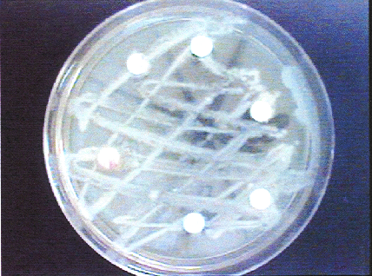

Dish 0% sulfur concentration

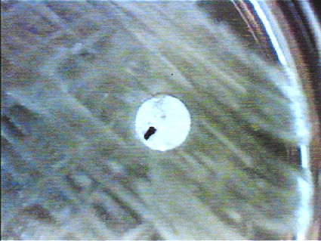

Dish 0% sulfur concentration close up

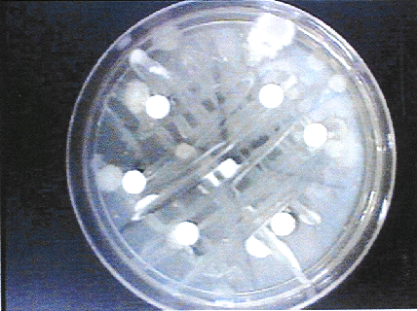

Dish 10% sulfur concentration

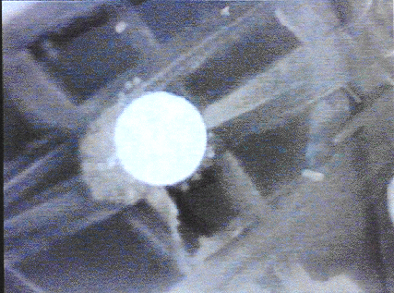

Dish 10% sulfur concentration close up

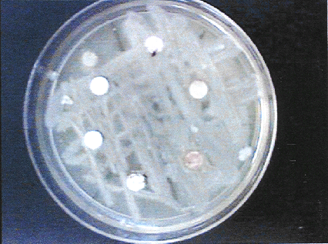

Dish 25% sulfur concentration

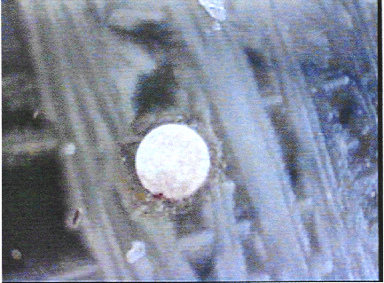

Dish 25% sulfur concentration close up

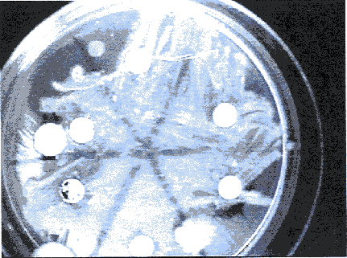

Dish 50% sulfur concentration

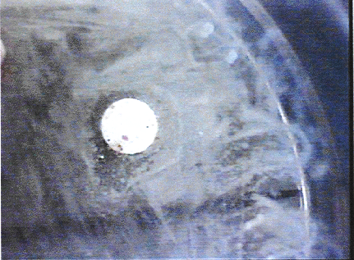

Dish 75% sulfur concentration close up

# **Experimentation (Daily) Log**

Pre January 1, 2001 – Gathering background information on the plant genus, *Agrostis* and the element Sulfur. Also gathering information on the prokaryote Bacillus Cereus. Experimentation has not yet started, but steps are being thought out and equipment has been gathered in the biology lab.

January 2, 2001 – 3 types of grass are obtained from the Pacific Seed Co. in Livermore, CA. Planting begins roughly 2:30 P.M. and ends around 5:00 P.M. Each small soil pot contains 15 grams of substances (dirt and sulfur). 5 different sulfur concentrations of soil are made for each of the 3 species of grass. 0%, 10%, 25%, 50% and 75% (Note: 75% sulfur concentration is too much sulfur, so we are afraid that the grass will not grow). Water is sprayed with a sprayer and we gave it 8 sprays per section.

January 3, 2001 – Jessica comes between 12 – 2 PM to water the plants. She comes again around 5:00 P.M.

January 4, 2001 – Hyunje comes during 12 – 2 PM to water the plants. He comes again around 5:00 P.M.

January 5, 2001 - Hyunje comes during 12 – 2 PM to water the plants. He comes again around 5:00 P.M.

January 6, 2001 - Hyunje comes during 12 – 2 PM to water the plants. Jessica comes around 5:00 P.M. At this point, each grass section has received the same amount of water as the others.

January 7, 2001 – Jessica comes during 12 – 2 PM to water the plants. She comes again around 5:00 P.M.

January 8, 2001 to March 2 – (Back to School) Jessica feeds plants in the morning before school starts daily. Hyunje checks on plants lunch time, around noon. By March 2, the hypothesis, problem, and procedure are completed.

February 2, 2001 – Moved the grasses to Mr. Simms’s (a biology teacher) room for better growing conditions. Grass begins to flourish soon after. The procedure is being written for the experiment. It is completed on Saturday, March 3, 2001.

March 5, 2001 – Grass is moved to Mr. Thiel’s (Our biology teacher) room. We plan to uproot the grass this week to start our experiment. The abstract and the acknowledge page is written and completed.

March 6, 2001 – Finished the Introduction.

March 7, 2001 – Started the experiment. Follow procedures carefully and efficiently. The experiment went well. Finished half of the experiment today. Get the results for these trials tomorrow.

March 8, 2001 – We tried to finish the experiment today. Some of the results are in. Record them in data charts. Don’t forget to keep everything the same. Get the results tomorrow.

March 9, 2001 – Finished the experiment and the obtained the results. Recorded into the data charts and graphed. Start our results and conclusion. Get a statistical analysis.

March 12, 2001 to March 16, 2001 – Work on Write up for the Science Fair. Most of it is completed except for the minor sections, such as the bibliography and the recommendations page.

March 17, 2001 – Finished Recommendations page.

March19, 2001 – Finished the Bibliography and works cited pages.

March 20, 2001 – Buy the poster board.

March 21, 2001 to March 24, 2001 – Worked on the display board and finished!! Our experiment and scientific journey is complete. We are a success.

March 25, 2001 – Get ready for the science fair.